***FLOOD MONITORING SYSTEM***

**Introduction:**

Flood monitoring and early warning system using the Internet of Things (IoT) is a network of sensors and devices that are used to collect real-time data about water levels, rainfall, and other environmental conditions in areas that are prone to flooding. The data collected by the sensors is transmitted to a central server or cloud-based platform, where it is analyzed and used to generate flood warnings.

IoT-based flood monitoring and early warning systems offer a number of advantages over traditional systems, including:

* Real-time data collection and analysis: IoT sensors can collect data at a much faster rate than traditional systems, which allows for earlier detection of flood risks.
* Wider coverage area: IoT networks can be deployed over a much wider area than traditional systems, which allows for more comprehensive flood monitoring.
* Improved accuracy: IoT sensors are becoming increasingly accurate and reliable, which leads to more accurate flood warnings.
* Lower cost: IoT sensors are relatively inexpensive to deploy and maintain, which makes them a more cost-effective solution for flood monitoring.

IoT-based flood monitoring and early warning systems can be used to protect people and property from the devastating effects of flooding. By providing early warning of flood risks, these systems can give people time to evacuate and take other protective measures.

Here is a brief overview of how an IoT-based flood monitoring and early warning system works:

1. IoT sensors are deployed in flood-prone areas to collect data about water levels, rainfall, and other environmental conditions.
2. The data collected by the sensors is transmitted to a central server or cloud-based platform.
3. The data is analyzed to identify flood risks.
4. If a flood risk is detected, a warning is generated and sent to the relevant authorities and/or the public.

IoT-based flood monitoring and early warning systems can be used to generate warnings in a variety of ways, such as through SMS text messages, email, social media, or mobile apps.

**DIAGRAM**

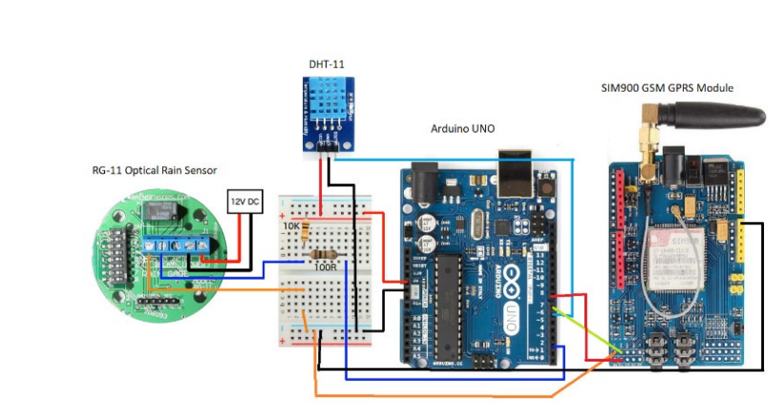

**COMPONENTS**

The components of a flood monitoring and early warning system can be broadly categorized into four groups:

1. Data collection and monitoring

This includes the sensors and other devices used to collect data on rainfall, river levels, soil moisture, and other relevant factors. Common data collection devices include:

* Rain gauges
* River level sensors
* Soil moisture sensors
* Meteorological stations
* Radar and satellite imagery

2. Data processing and forecasting

The data collected from the monitoring network is processed and analyzed to generate flood forecasts. This is typically done using hydrological and meteorological models.

3. Warning dissemination

Once flood forecasts have been generated, they need to be disseminated to the public and other stakeholders in a timely and effective manner. Common warning dissemination methods include:

* SMS
* Email
* Radio and television broadcasts
* Social media
* Community loudspeakers

4. Emergency response and preparedness

Flood monitoring and early warning systems should also be integrated with emergency response and preparedness plans. This ensures that the information generated by the system is used to take effective action to protect people and property.

In addition to the above components, flood monitoring and early warning systems may also include other features such as:

* Real-time data visualization and dashboards
* Decision support tools
* Public education and awareness programs

The specific components of a flood monitoring and early warning system will vary depending on the specific needs of the community or region it is designed to protect. However, all systems should include the core components listed above.

Here is an example of how the different components of a flood monitoring and early warning system might work together:

* Rain gauges and river level sensors are installed throughout a community.
* The data collected from these sensors is transmitted to a central data processing center.
* Hydrological and meteorological models are used to generate flood forecasts based on the collected data.
* Flood warnings are disseminated to the public and other stakeholders via SMS, email, radio and television broadcasts, social media, and community loudspeakers.
* Emergency response teams are mobilized to take steps to protect people and property in areas at risk of flooding.

Flood monitoring and early warning systems can play a vital role in reducing the loss of life and property from floods. By providing timely and accurate warnings, these systems can give people enough time to evacuate to safety and take other protective measures

**FLOW CHART**

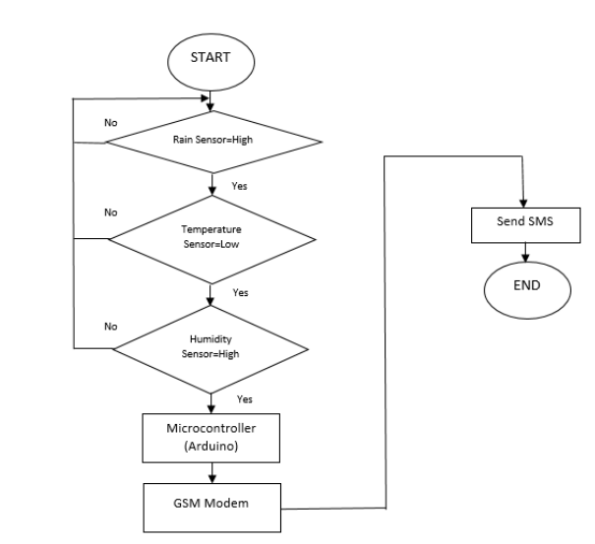

When the rain sensor detects the raindrop and the temperature-humidity sensor detects, the data from the sensor will send through the SIM900 shield. To fulfill the condition to send message to the register user, the sensor must reach its specific limit as instructed in the microcontroller (Arduino UNO). From there, the controller conducts the data gathered from the sensor and then applies coding and programming to create the desired feature. The data then be sent to the GSM modem, where the GSM modem will send the notification to the user

[1] Tipping bucket

Tipping bucket is replaced with low maintenance alternative

[2] "It’s Raining”

The sensor will normally close when a skylight at the first sign of the rain, normally open when the rain stops

[3] Condensation Sensing

Continuously monitors the clarity of the sensing surface.

[4] Wiper control

Control the wiper from off through intermittent and steadyslow speeds.

[5] Irrigation Control

Measure both rain accumulation and rain intensity

[6] Drop Detection

The mode used for external data interpretation.

The DIP switches must be set so that the RG-11 rain sensor will behave according to the instructions given in the instruction manual. Controls such as 5, 6, and 7 set the overall mode operation, and other switches (1, 2, 3, 4, 5) adjust the behavior within the modes. Also noted that RG-11 could not drive 120/240 VAC load without an external relay because it requires only low voltage AC/DC supply and prevents directly powered from the 120/240 VAC grid, which could cause damage to the sensor.

**CONCLUSION**

* + - A Flood Monitoring and Early Warning System is a crucial tool for mitigating the devastating impact of floods on communities and environments.
    - This System harnesses various technologies and data sources to provide timely and accurate information about floods conditions, allowing for proactive measures to be taken.